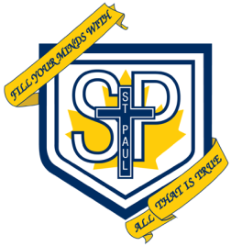Dear Parents / Guardians,
In order for students to be successful in the Dance Arts courses specific supplies and attire are needed. We have endeavoured to keep the list of items to a minimum. Each student must provide the following for their personal use:
Uniform: A Black Outfit
- Black Dance Shorts
- Beige Dance Tights (not Nylons)
OR
- Black Dance/Yoga Pants (Able to stretch for full flexibility)

- Black Shirt (No Spaghetti Straps)

- Jazz/Ballet Shoes (Leather or Canvas)
* Tights, Shorts and Shoes available at: Malabar, Brio, Payless, Audrey’s Costume and Danceware.

Supplies
- Hair Elastics (2)
- Bobby Pins or Hair Clips
- Pencil or Pen
- Duotang with lined paper

Thank you in advance for your support in this area.

Sincerely,
Ms. Melody Rotondo
St. Paul Dance Teacher

